## What is OneDrive?

OneDrive is an online cloud-based service for storing and editing files. OneDrive enables you to save, search and share files securely.

## Saving a file before editing, including re-naming and moving into a different folder (for example individualising a Template Supervision)

When you are sent a file to fill out, please save it to your personal drive before editing it. You can download the attachment to any device, this option is available via the download symbol which may vary from device to device and differing email platforms. If you are using Google, Android or Windows you can simply download the file by pressing the download button [Figure 1]. If you are using an Apple product, tap on the attachment to open it click on the arrow next to the document title to open the drop-down menu and select save to files [Figure 2].

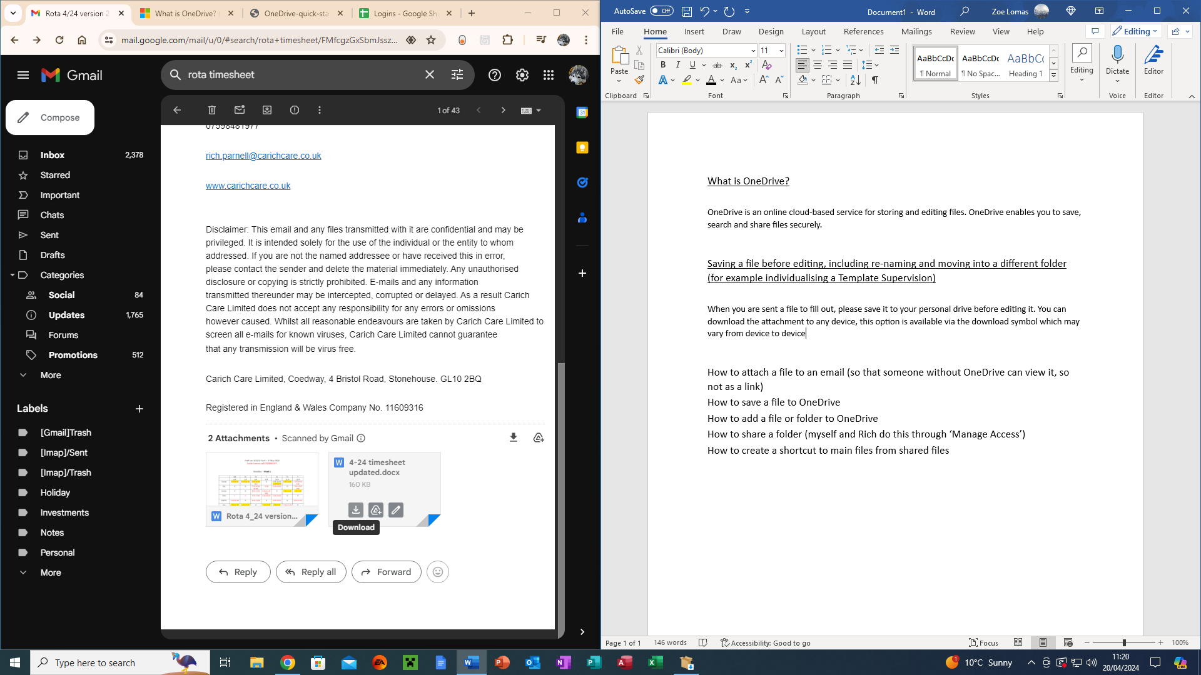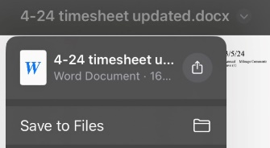

Figure 1 Google/Android/Windows products

Figure 2 Apple/iOS products

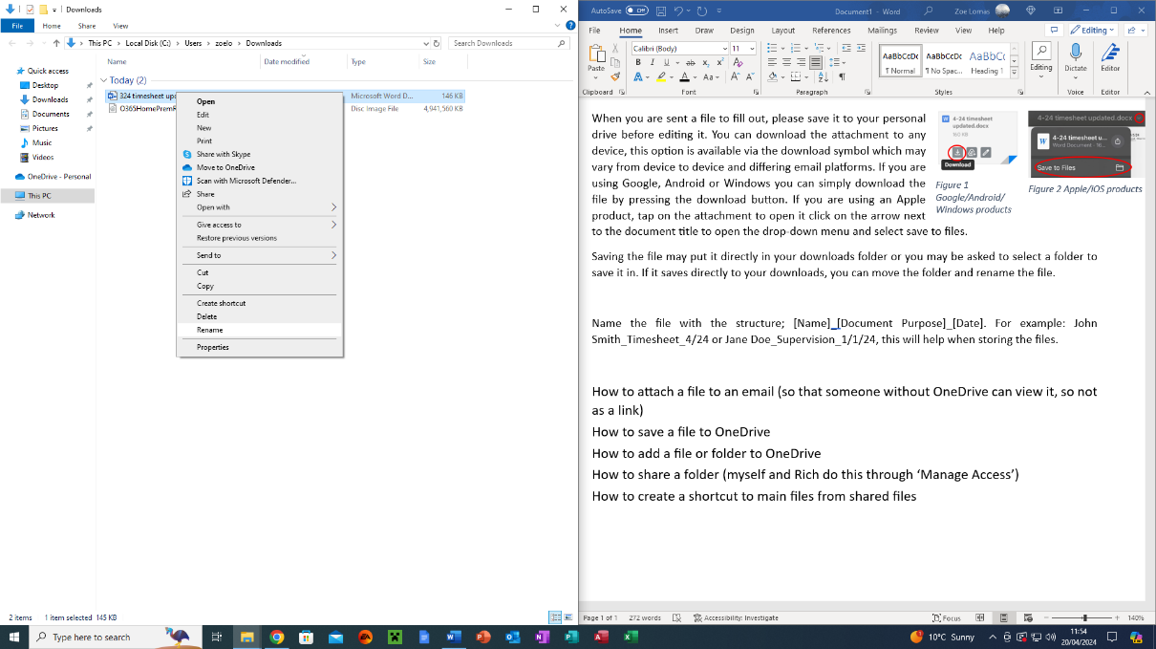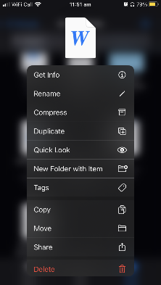

Figure 3 Renaming on Windows

Figure 4 Renaming on iOS

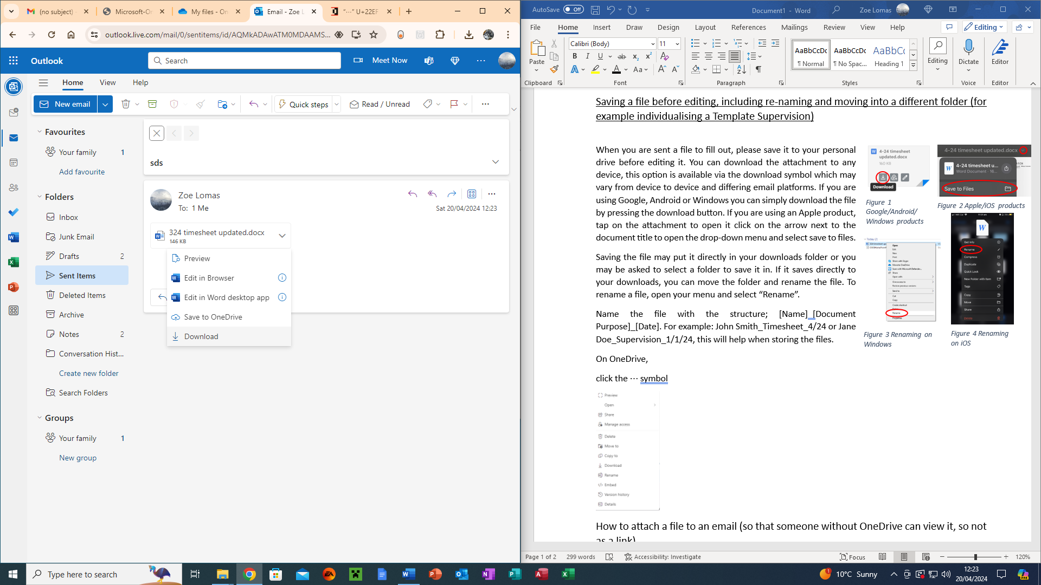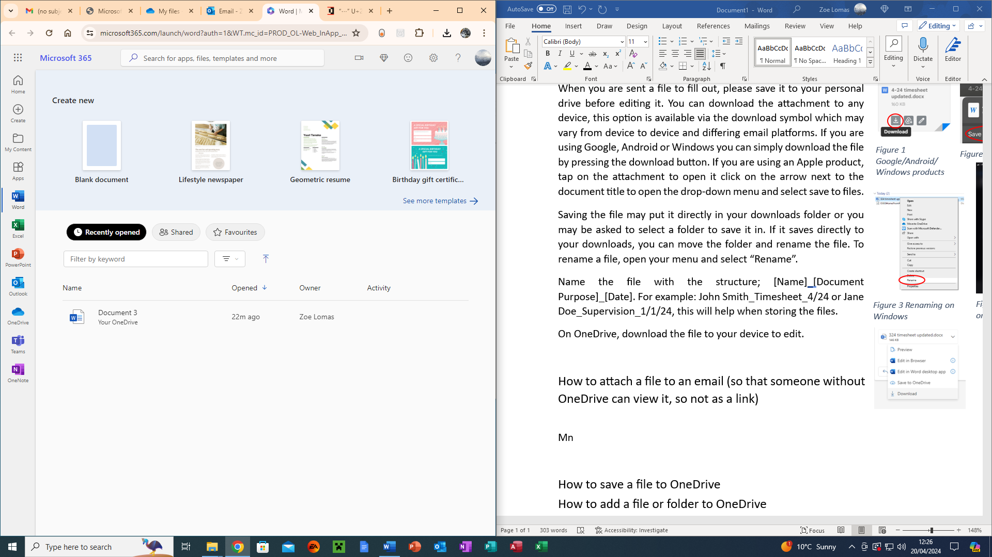

Figure 5 OneDrive Download

Figure 6 OneDrive Upload Symbol

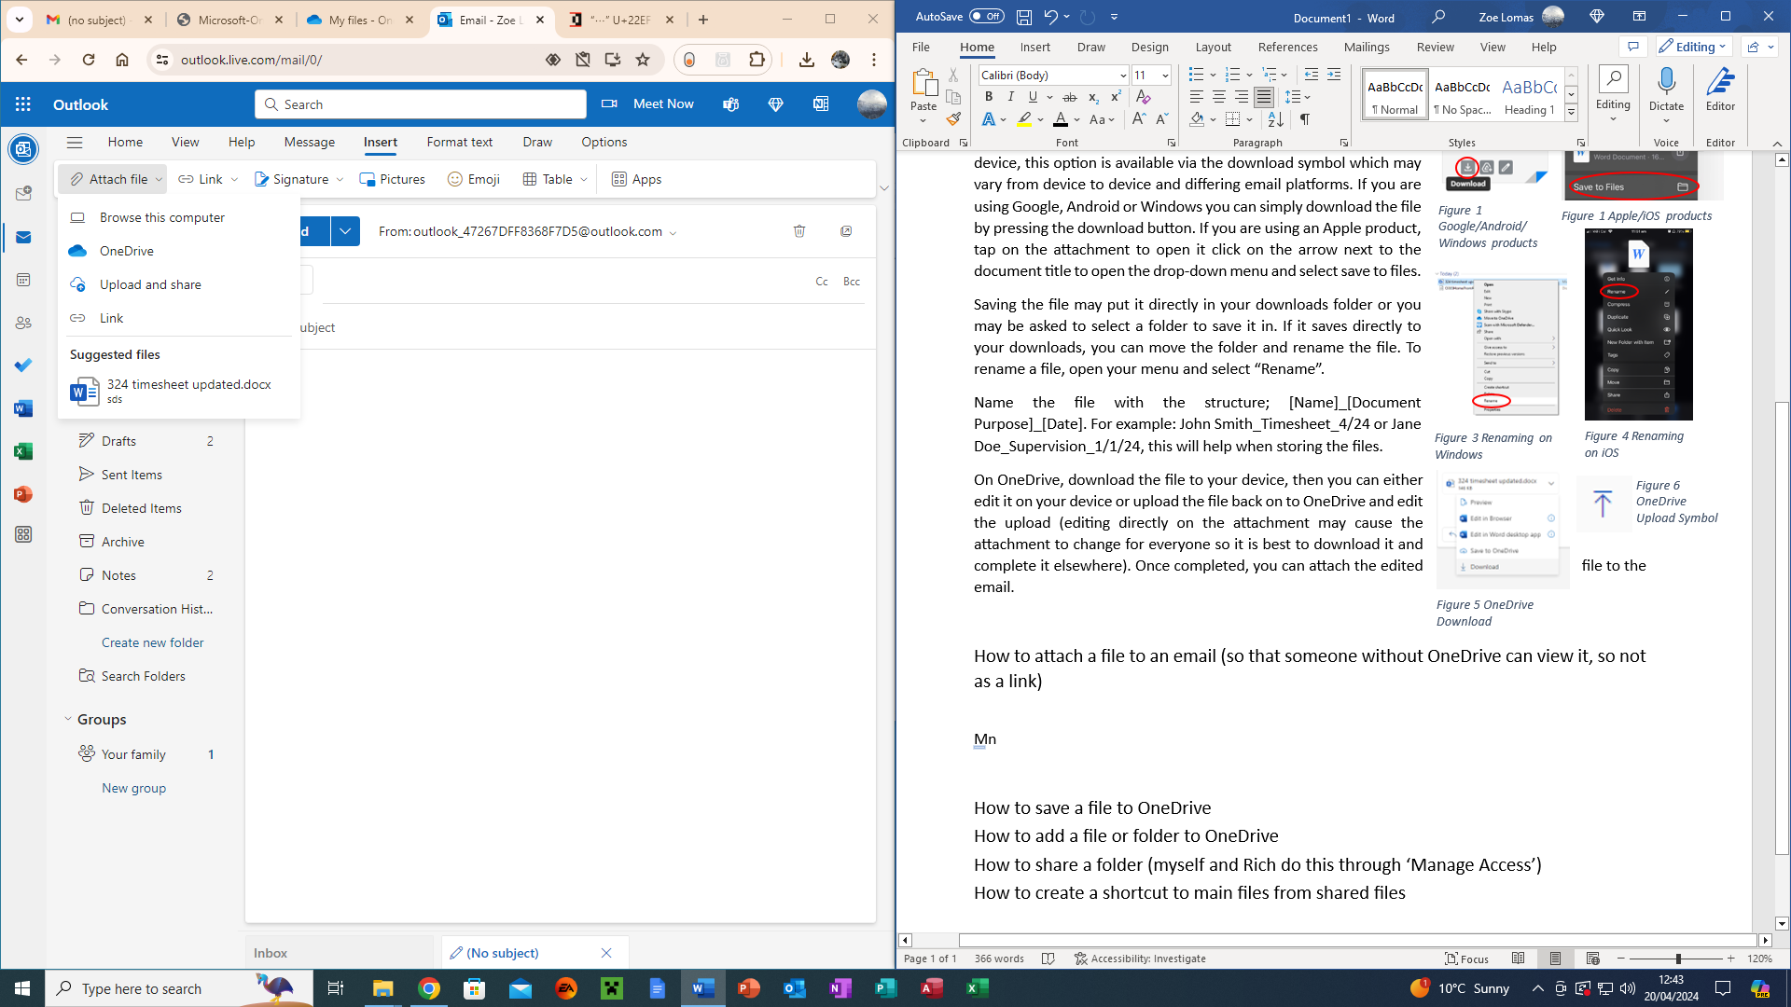

Figure 7 Outlook Attachments

Saving the file may put it directly in your downloads folder or you may be asked to select a folder to save it in. If it saves directly to your downloads, you can move the folder and rename the file. To rename a file, open your menu and select “Rename” [Figure 3 & 4].

Name the file with the structure; [Name]_[Document Purpose]_[Date]. For example: John Smith_Timesheet_4/24 or Jane Doe_Supervision_1/1/24, this will help when storing the files.

On OneDrive, download the file to your device [Figure 5], then you can either edit it on your device or upload the file back on to OneDrive [Figure 6] and edit the upload (editing directly on the attachment may cause the attachment to change for everyone so it is best to download it and complete it elsewhere). Once completed, you can attach the edited file to the email, either from the computer or from your drive [Figure 7].

## How to attach a file to an email (so that someone without OneDrive can view it, so not as a link)

If you are sending a file from OneDrive to someone who doesn’t have access to OneDrive, you select the file as you normally would; Attach File > OneDrive, select the file and it will automatically display a “Share Link” button at the bottom with a down arrow next to it. If you click the drop-down arrow to the right of the button you can select “Attach” which attaches the file itself rather than the link to your drive.

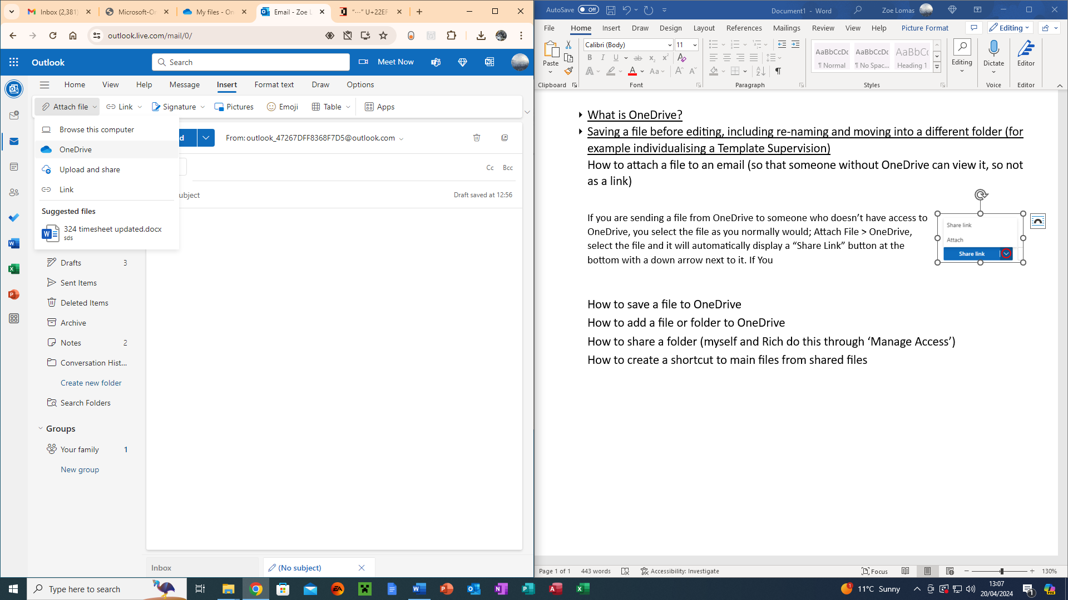

Figure Attaching from OneDrive

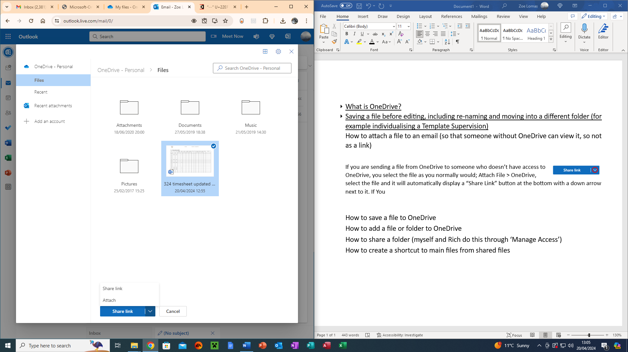

Figure Attaching files without links.

## How to save a file to OneDrive

If you are saving an email attachment, there is a chance it saved automatically. You can check by opening the file attatchment and looking for a cloud symbol with a tick in it next to the file name [Figure 1]. However if it has not saved, you can click File>Save as and save the file to your drive [Figure 2].

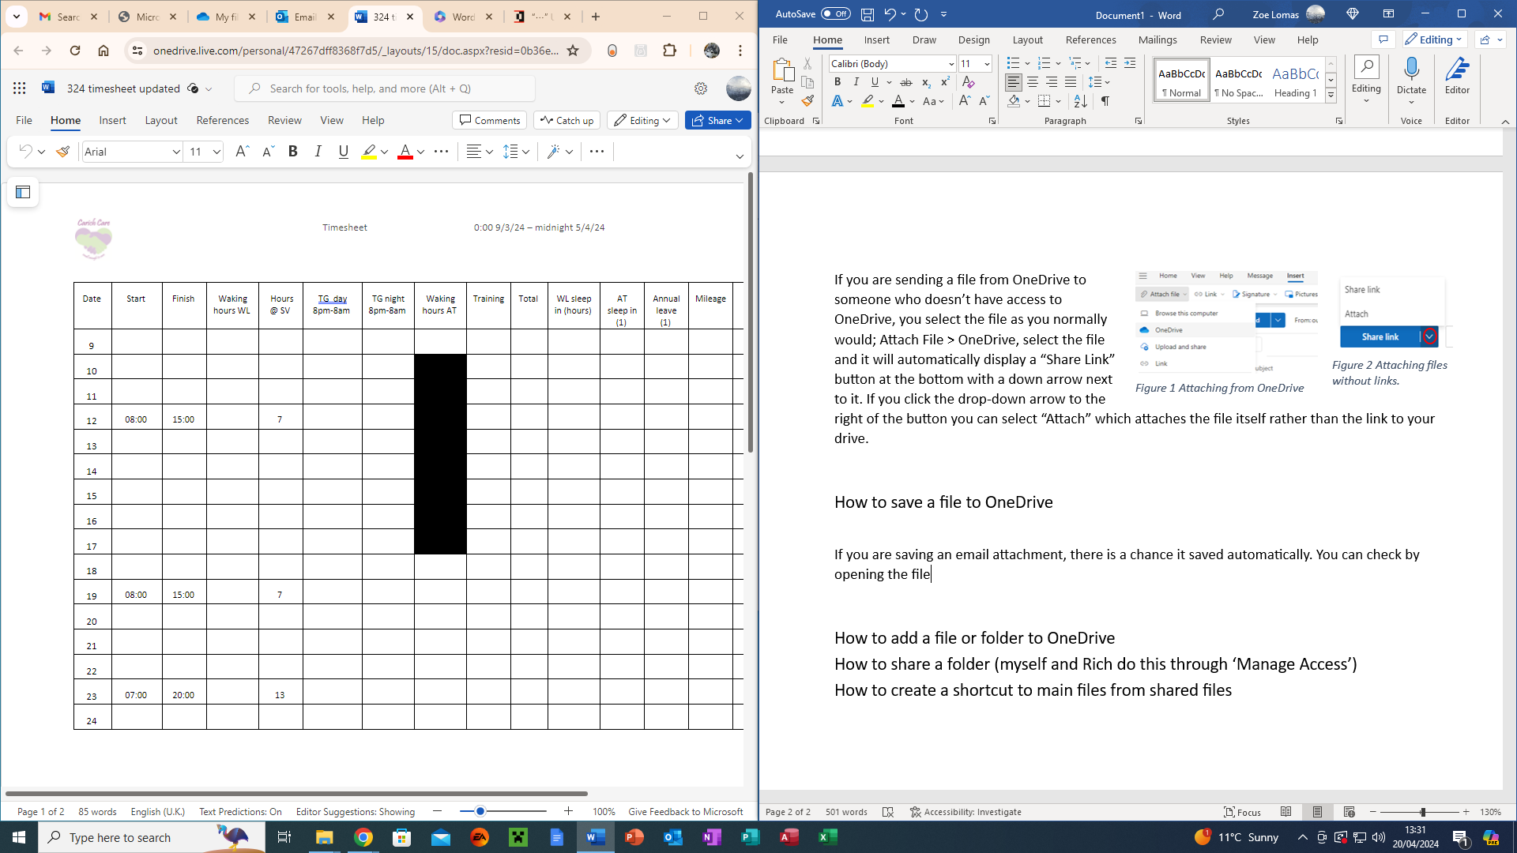

Figure 1 Cloud Symbol

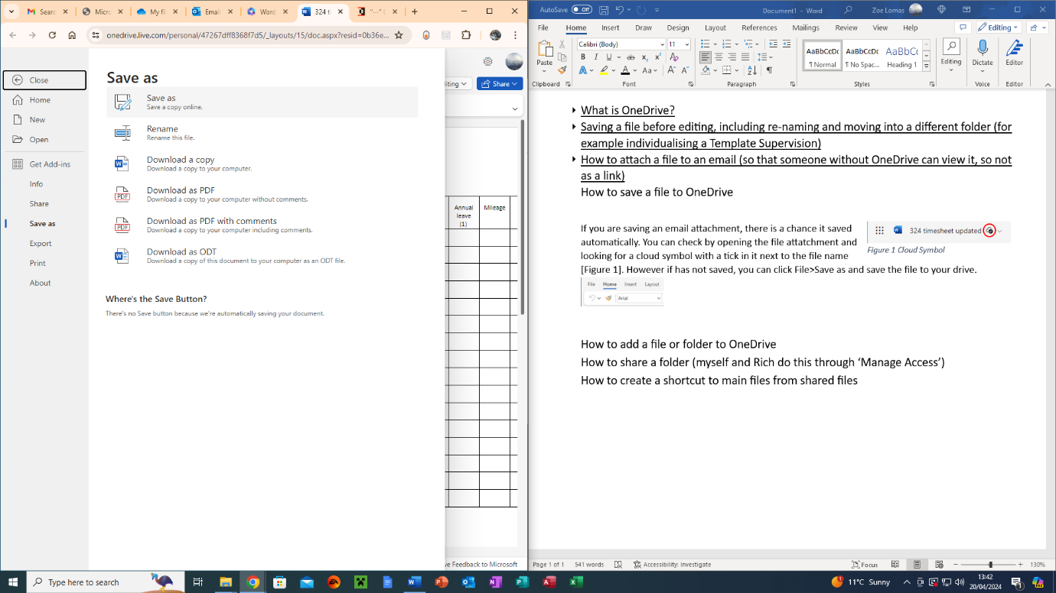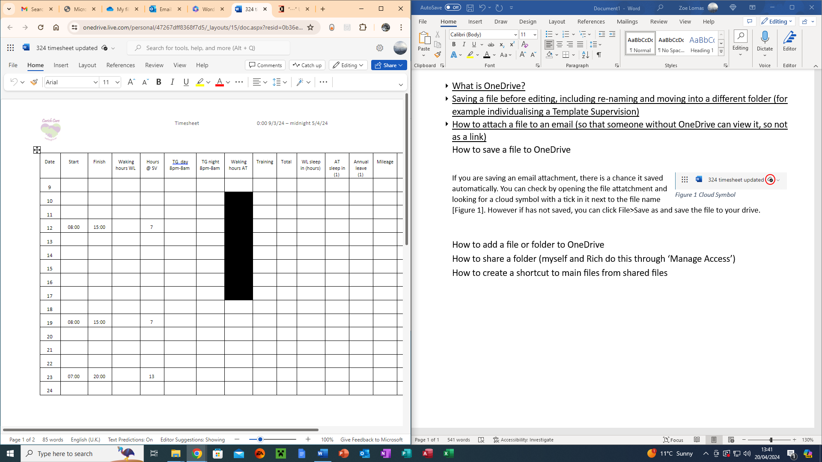

Figure 2 Saving the file.

## How to add a file or folder to OneDrive

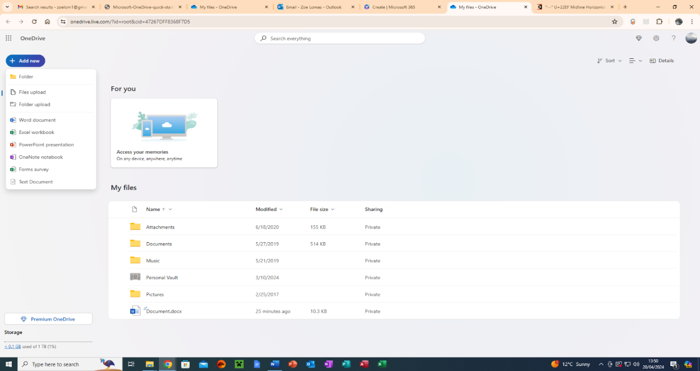

Figure 1 OneDrive Add New menu.

When you open OneDrive, there’s an “Add New” button. Once you click it there is a drop-down menu, if you need a blank folder you can click “Folder”, if you need any kind of blank document, you can click the corresponding icon (e.g., Word for text, Excel for spreadsheet, PowerPoint for slideshows etc.). If you have a pre-existing file/folder, you can click file/folder upload and select the file/folder(s) from your device’s drive.

## How to share a folder

To share a folder, open the drop-down menu by clicking ⋮ and click Manage Access > Start Sharing. In the Share Attachments window, you can fill in the emails of people whom you want to see/be able to edit the attachment or you can click the “Copy link” button and send the file via the link.

